Technical Documentation
E-Commerce Platform (Full-Stack Project)

1. Project Description
This project is a full-stack E-commerce web application built using modern web technologies.
It simulates a real-world online store where users can browse products, view details, and manage a shopping cart.
The system also includes an Admin panel that allows product management through secure authentication.

Project Objectives
- Build a responsive online store
- Apply frontend and backend development skills
- Implement RESTful APIs
- Handle dynamic data using a database
- Simulate a real business environment

Technologies Used
Frontend:
- React.js
- Vite
- Tailwind CSS
- Axios
- React Router DOM
- Local Storage
- Fake API Data

2. Setup Instructions
Frontend Setup
- Navigate to frontend folder:
cd frontend
- Install dependencies:
npm install or bun install
- Start development server:
npm run dev

3. Folder Structure
Frontend (React SPA)
The frontend is built using React with a component-based architecture.
Main Structure
- src/ → Main source code
- components/ → Reusable UI components
- pages/ → Application pages (routes)
- context/ → Global state management
- services/ → API and data handling
- data/ → Static mock data
- styles/ → Global styling

Components
- Layout.jsx → Handles main layout (Navbar & Footer)
- Toast.jsx → Displays notifications

Pages
- ProductList.jsx → Displays product catalog
- ProductDetail.jsx → Shows product details
- Cart.jsx → Shopping cart page
- Register.jsx → User registration
- AdminLogin.jsx → Admin authentication
- AdminDashboard.jsx → Product management (CRUD)
- AboutUs.jsx → About page
- ContactUs.jsx → Contact form

Context (State Management)
- AuthContext.jsx → Manages authentication
- CartContext.jsx → Handles cart logic

Technologies:
Frontend:
- React.js (Component-based architecture)
- Vite (Fast build tool)
- Tailwind CSS (Modern UI styling)
- React Router DOM (Routing)

State Management:
- React Context API

Data Handling:
- LocalStorage (Cart & Auth simulation)
- JSON files (Mock data)

Tools & Libraries:
- Axios (API handling)
- Toast notifications
- PostCSS

Main Files Explanation:
- App.jsx:
Handles the main routing and layout of the application.

- main.jsx:
Application entry point and React initialization.

- Layout.jsx:
Defines the main structure of the UI including Navbar and Footer.

- AuthContext.jsx:
Manages authentication logic and user state.

- CartContext.jsx:
Handles cart operations such as adding, removing, and updating items.

- ThemeContext.jsx:
Controls dark mode and theme switching.

- api.js:
Provides an abstraction layer for API calls (currently mocked).

- localData.js:
Handles interaction with local Storage for data persistence.

- ProductList.jsx:
Displays all products in a grid layout.

- ProductDetail.jsx:
Shows detailed information for a selected product.

- AdminDashboard.jsx:

Provides admin functionality to manage products (CRUD).

Functional:
- Product browsing
- Cart management
- Admin CRUD
- Authentication
- Dark mode
Non-Functional:
- Responsive design
- Performance
- Clean UI/UX
- Scalability
- Maintainability

🎨 7. Features
User:
- Browse products
- View product details
- Add/remove items from cart
- Responsive design
Admin:
- Login system
- Manage products (CRUD)
- Protected dashboard

Website Pages Preview
- Hero Section
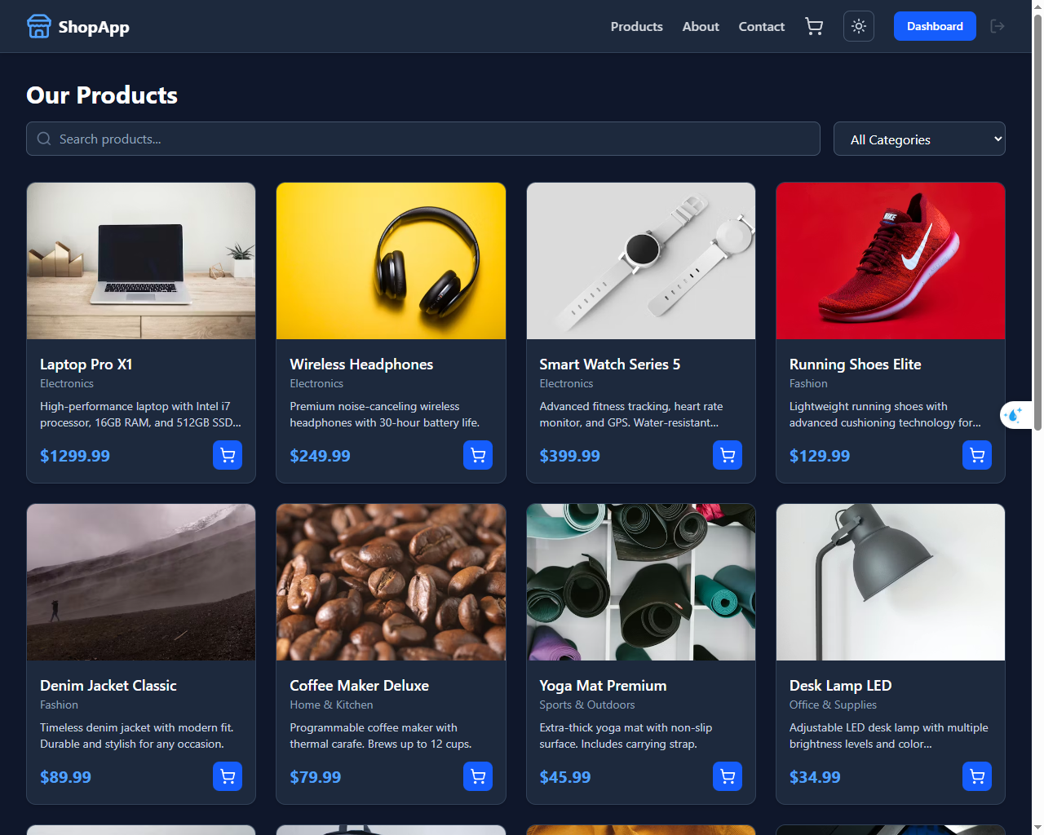
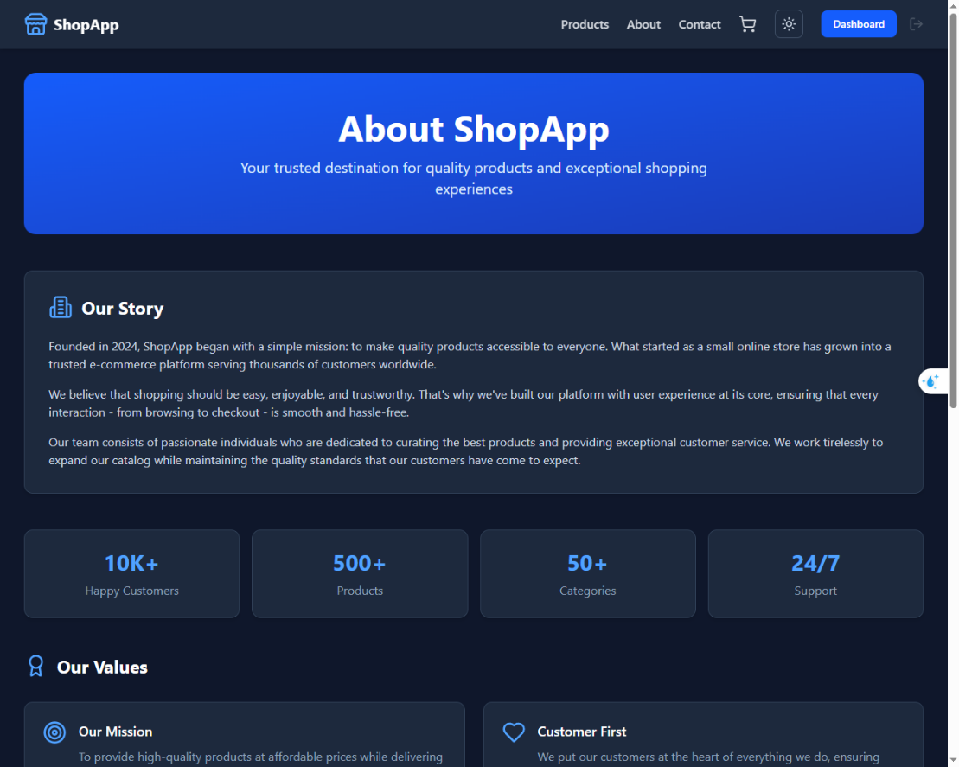
- About Page

- Contact Page
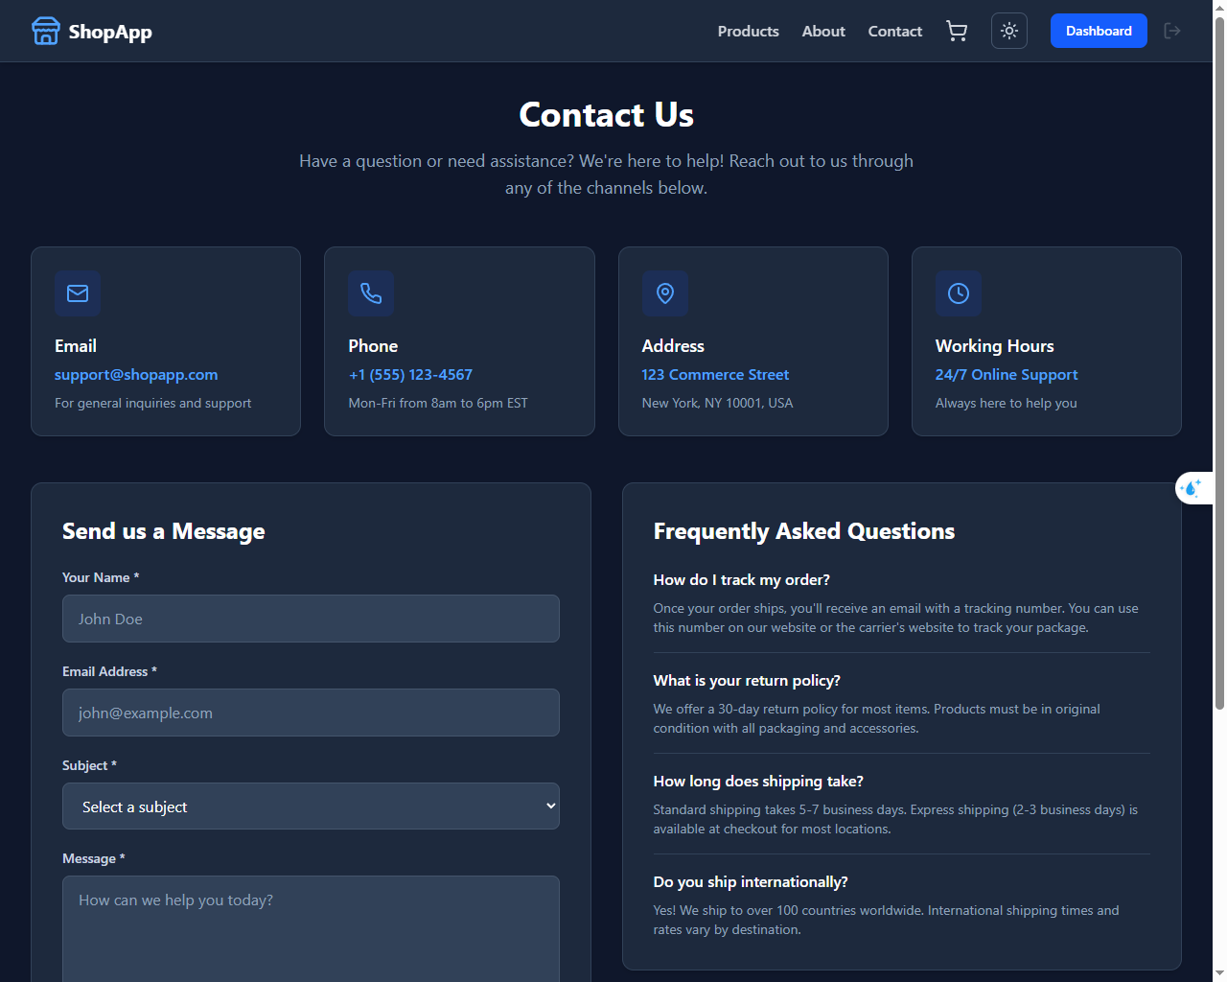
- Cart Shopping
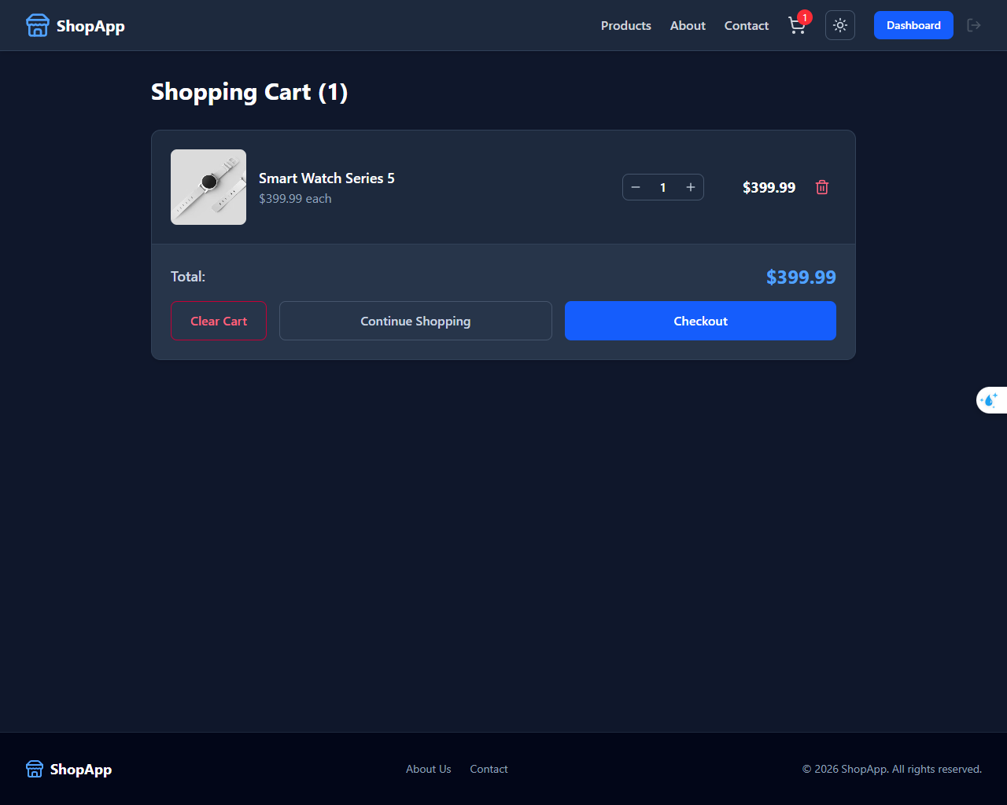
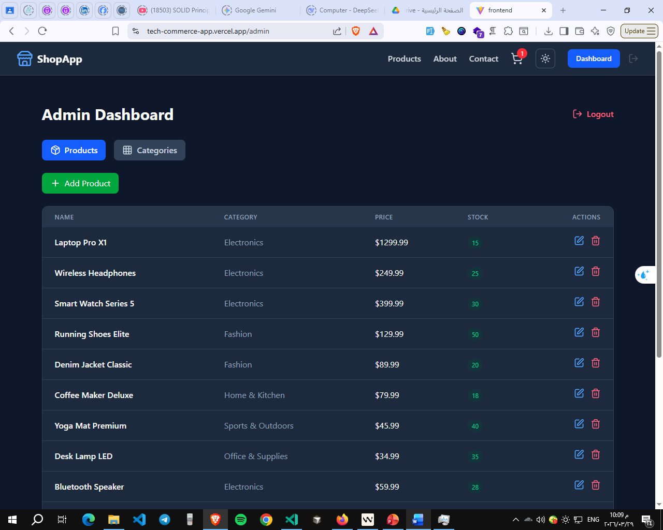
- Admin Dashboard Page

8. Challenges & Solutions
- Challenge 1: Managing state without backend
- Solution: Used React Context API and local Storage for persistence

- Challenge 2: Authentication without real server
- Solution: Simulated auth system using local Storage and protected routes

- Challenge 3: Component reusability
- Solution: Built modular and reusable components for scalability

- Challenge 4: UI responsiveness
- Solution: Used Tailwind CSS with mobile-first approach

- Challenge 5: Deployment issues
- Solution: Switched to frontend-only architecture using fake APIs

Reflects:
This project helped me understand:
• How to build a real-world web application from scratch
• How frontend and backend communicate using APIs
• The fundamentals of RESTful API design
I also improved my problem-solving skills and learned how to structure clean, maintainable, and scalable code.

This experience gave me more confidence in building full applications and thinking like a professional developer.
10. Conclusion
This project successfully demonstrates the ability to build a complete E-commerce platform using modern web technologies.
It covers both frontend and backend development and simulates real-world business logic.

Prepared by: Ahmad Abdallah
Date: March 2026

